Smart Control of Traffic Light Using Artificial Intelligence

Now-a-days due to increasing number of vehicles it’s becoming difficult to manage traffic efficiently which leads to longer duration journey and maximum petrol consumption and to avoid this problem standard techniques was introduce such as manual traffic control which require more number of traffic person, static time traffic control which is not effective as it will use same timer for all lanes with heavy and light traffic and sensor based traffic management but this require heavy budget of sensor deployment to sense and manage traffic based on density.

To overcome from above issues author of this paper is utilizing traffic cameras and YOLO object detection algorithms to estimate traffic density at all lanes and then adjust red and green signal time. Cameras will take snapshot of all lanes every five seconds and then estimate traffic at lanes and based on density green and red signal time will be adjusted.

In propose paper author has used PYGAME technique to simulate traffic environment and the used YOLO real environment to detect and count traffic from real traffic videos

To implement this project we have designed following modules

1. Run Traffic Simulation: using this module we can start PYGAME traffic simulation where you can see traffic control based on traffic density
2. Run Yolo Traffic Detection & Counting: using this module we will upload traffic videos and then YOLO will detect traffic vehicles and estimate their density with speed

SCREEN SHOTS

To run project double click on ‘run.bat’ file to get below output

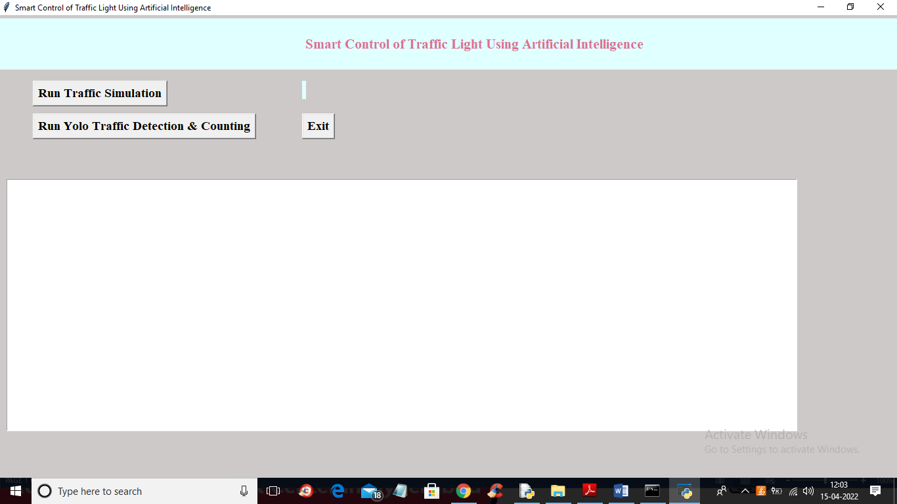

In above screen click on ‘Run Traffic Simulation’ button to start PYGAME simulation and get below output





In above screen you can see PYGAME simulation output and at each lane traffic density is calculated and then adjust green and red line. This simulation run in INFINITE loop so you press ‘windows’ key from keyboard and then close application and then restart and run second YOLO module

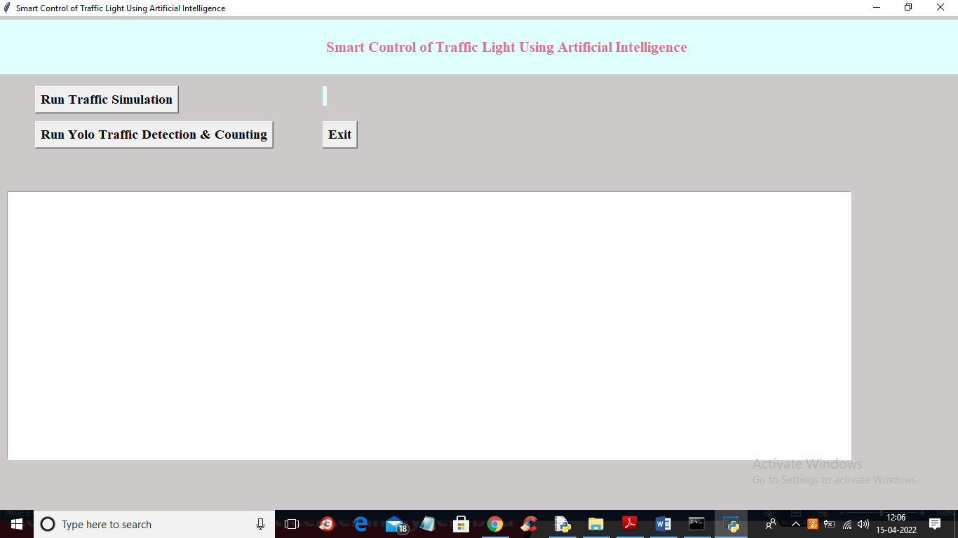

Now in above screen click on ‘Run Yolo Traffic Detection & Counting’ button to upload traffic video and then estimate traffic density

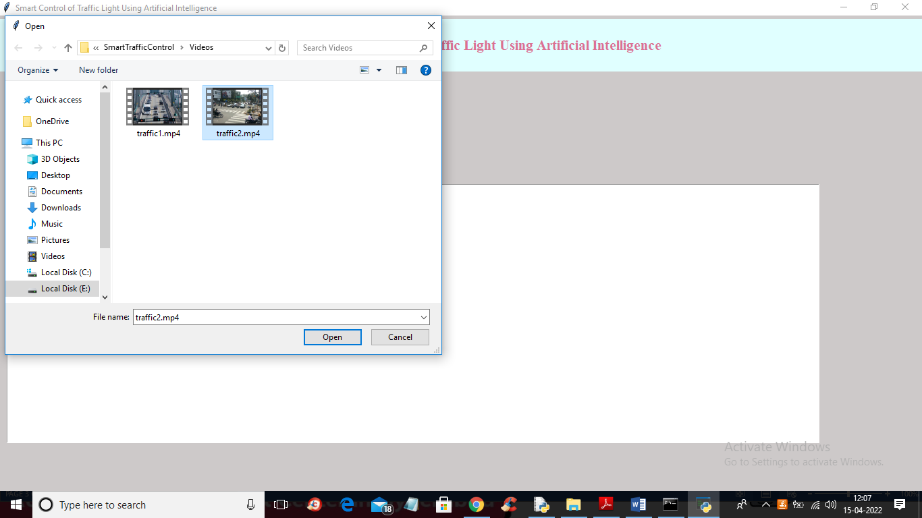

In above screen selecting and uploading ‘traffic2.mp4’ video and then click on ‘Open’ button to get below output

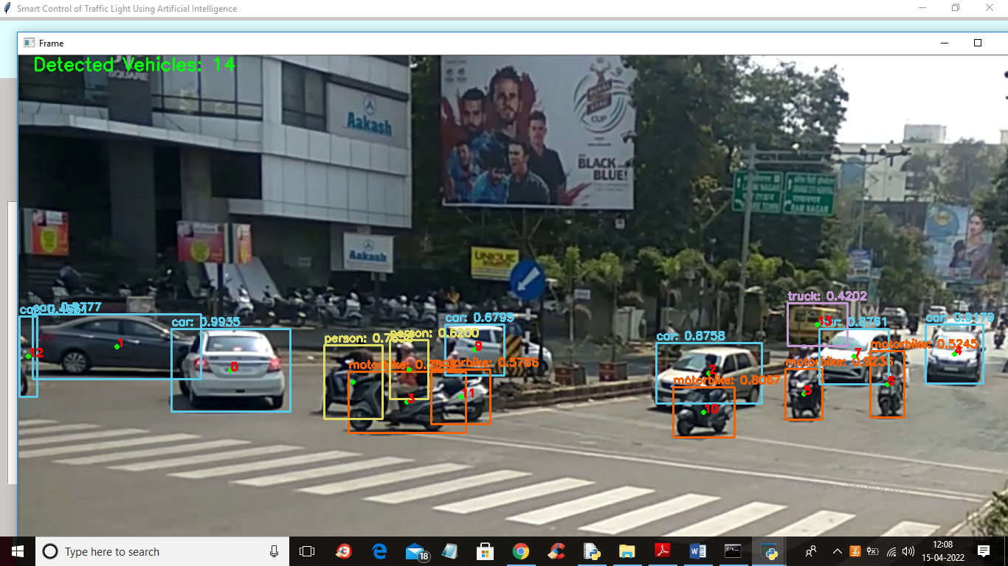

In above screen detecting traffic and then estimating its count and based on that traffic time will be adjusted. YOLO runs very slowly in normal laptop so let it finish all frame processing then u will get output.mp4 file which you can play as normal video with traffic density.

